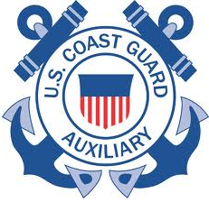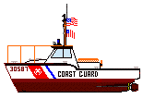

***United Sta United States Coast Guard Auxiliary***

***FLOTILL* Flotilla014-18-08**

**North Fork, Long Island NY**

December 7, 2024

Welcome aboard to the **BA (Boat America)** course taught by the US Coast Guard Auxiliary with all volunteer certified instructors on Saturday Dec 7, 2024 from 8 am to 5 pm at the Cutchogue New Suffolk library.

Bring your own snacks, water, and lunch. There will be a one-hour break for lunch. You may stay in the library or leave the building for lunch.

At the end of the day, you will take a closed-book test of 60 multiple choice questions, 1-50 from the enclosed Boat America textbook and 51 to 60 from the enclosed NY State Boater’s Guide. You are allowed 1½ hours to complete the test, many finish before then.

Before the first class read through both enclosed books and study the review questions at the end of the text book. Those questions will be on the test.

After successful completion, you’ll receive a wallet-sized ID card and a Certificate of Accomplishment. The name you submitted at registration will be printed on these documents and must match NY State driver’s license to qualify for the anchor printed on your license.

When leaving the Cutchogue New Suffolk library you may ask the librarians to laminate your card and certificate.

These documents:

* Permit individuals 14 years of age and over to legally operate a PWC (Personal Water Craft).
* Satisfy the requirements of NY State boating safety.
* Are approved by NASBLA (National Association of State Boating Law Administrators).
* May qualify you for an insurance discount on your vessel.

Your instructors look forward to meeting you.