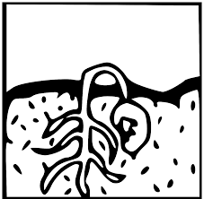
WINTER SEED SOWING
An easy way to start seeds OUTDOORS in January, February & March
SEEDS (Hundreds of seeds available in catalogs & displays. A few are listed below.)
Annuals: marigolds, cosmos, calendula, salvia, celosia, zinnias
Perennials: black eyed susans, bee balm, daisies, echinacea, coreopsis
Vegetables: lettuce, arugula, tomatoes, cucumbers, peppers, eggplant

SOIL (GROWING MEDIUM)
No garden soil, bagged soil, or compost to avoid DAMPING OFF
Potting MIX: excellent Potting Soil: very good

CONTAINERS
- FIND clear or semi transparent containers deep enough to hold 2-3 inches of potting mix. (Recycle milk jugs, juice, water containers, produce and takeout clamshells)
- RINSE/CLEAN
- Make 4-5 drainage holes in bottom. Make holes in top/ take off cap
- Cut an opening about 2 inches ABOVE where potting mix will be
- Moisten potting mix. Place in container
- Plant seeds (depth related to size, earliest to transplant first)
- Tape cut opening
- LABEL container
9. Set OUTSIDE. Needs sun, rain/snow, good drainage, secure spot so not blown over by the wind
Seedlings will emerge in spring. Be patient. Transplant to the garden when temperatures outside are favorable for that plant

Community Horticulture Roxanne Zimmer rz378@cornell.edu

